Site-specific dehydration of olivines from San Carlos and Kilauea Iki

# Introduction

The diffusivity of hydrogen in olivine is a fundamental physical quantity critical for understanding a wide range of earth and planetary processes, most notably for understanding the deep water cycle. Water can affect global-scale phenomenon such as melting relations and strength, and so in turn may control mantle rheology and the occurrence of plate tectonics (Keppler and Smyth 2006; Bell and Rossman 1992). Accurate knowledge of the diffusivities also has great potential to serve as a chronometer to determine magma ascent times from hydrogen diffusion profiles in olivine phenocrysts.

More about usage and background, H incorporation mechanisms, previous diffusivity measurements…

Some background about Kiki and SC. Helz paper: Kiki QMF+1/2 or so.

# Experimental methods

## Sample selection and preparation

Olivines from San Carlos, AZ and Kilauea Iki were chemically characterized and used for H diffusion experiments. The San Carlos olivine similar to that used in previous hydration experiments (Mackwell and Kohlstedt 1990; Kohlstedt and Mackwell 1998) was provided by David Kohlstedt. Here we extend that work by examining site-specific dehydration behavior. The Kilauea Iki olivines were collected from scoria from the 1959 Episode 1 eruption of Kilauea Iki and have been described in detail by David Ferguson (Ferguson et al. 2016), who provided the samples. The Kilauea Iki samples are of great interest because they provide the first direct experimental measurements of H diffusion in all 3 crystallographic directions of inclusion-free olivine phenocrysts.

A large crack and inclusion-free piece of San Carlos olivine, SC1 (IGSN: IEFERSCO1), was oriented by Laue camera at Cornell University and then cut into a series of smaller pieces approximately 2-3 mm long on each side using a diamond saw. One of the resulting sub-pieces, SC1-1 (IGSN: IEFERJAI3), was polished with 0.25 μm diamond paste and used to estimate the initial water concentration by FTIR. Additional pieces of SC1 were used to test the hydration procedure, and pieces SC1-7 (IGSN: IEFERJAI9) and SC1-2 (IGSN: IEFERJAI4) were partially hydrated and then polished with 0.25 μm diamond paste for FTIR. SC1-2 was then sequentially dehydrated with FTIR profiles measured after each dehydration step and afterwards analyzed by EMPA and SIMS.

A large, relatively clear piece of the Kilauea Iki olivine, Kiki (IGSN: IEFERJAIC), was oriented based on morphology and polished into a block shape of dimensions 2 × 1 × 1.3 mm. The orientations were then confirmed by electron backscatter diffraction (EBSD) at the American Museum on Natural History (AMNH). The untreated Kiki sample was characterized by EMPA, SIMS, and polarized FTIR prior to dehydration.

Sample thicknesses in all three directions were measured with a digital micrometer accurate to within ± 5 μm. Additional details for all samples, including images and sample dimensions, are available online at geosamples.org.

## Electron microprobe analysis

Major elements of SC1-2 and Kiki were analyzed by electron microprobe at AMNH along traverses parallel to those on which water measurements were made to confirm homogeneity of the samples. The beam current was 20 nA, and the accelerating voltage was 15 kV.

## Initial water concentrations

The initial water concentration in each olivine was estimated using both polarized FTIR and SIMS. Polarized FTIR measurements were performed at AMNH using the Thermo Nicolet Nexus 670 infrared spectrometer and Thermo Nicolet Continuum 15× infrared microscope with a resolution of 4 cm-1, spot sizes of 100 × 100 μm, an average of 200 scans, and a ZnSe polarizer. Initial water concentrations were estimated from 3 orthogonal polarized measurements (Libowitzky and Rossman 1996; Shuai and Yang 2017) by applying the Bell and Withers calibrations (Bell et al. 2003; Withers et al. 2012). To account for the large error associated with baseline choice, 3 different baselines were drawn, and the resulting areas were averaged. Traverses along all three directions did not show significant zonation in bulk or peak-specific water in the untreated samples.

Erik Hauri measured the C, H, F, P, and Cl concentrations by nanoSIMS along traverses parallel to [001] in SC1-2 and parallel to [010] in Kiki as part of the CIDER workshop on electrical conductivity in hydrous olivine. SIMS measurements were made before Kiki was dehydrated but after the final dehydration heating step for SC1-2. Because the area under the O-H stretching peaks with the electric vector E || [100] is equal to for the untreated SC1-1 (7±5 cm-2) and partially hydrated and then dehydrated SC1-2 (7±6 cm-2), the SIMS measurements of the hydrated and then dehydrated SC1-2 were taken as a reasonable estimate of the initial water concentration in SC1.

## Hydration of San Carlos olivine

Two pieces of previously oriented San Carlos olivine SC1, SC1-7 and SC1-2, were partially hydrated in a ¾” Boyd-type piston cylinder apparatus with a BaCO3 pressure medium using a procedure broadly similar to that of Jollands et al. (2016). Here the samples were placed in copper capsules and surrounded by liquid distilled H2O and a powdered mixture of Ni and NiO to control oxygen fugacity and San Carlos olivine and enstatite to control silica activity (Figure 1). Temperatures were controlled with aD-type (W3%Re-W25%Re) with control precision of ±2°C and probable accuracy of ±20°C. After rapid quenching followed by relatively slow decompression, the capsules were pierced with a drill to confirm water was still present and then dissolved overnight in a mixture of 1:1 H2O to HNO3. The rectangular parallelepiped samples were then mounted in CrystalBond, polished with 0.25 μm diamond paste on all sides, and cleaned in acetone.

SC1-7 was heated for 7 hours at 10 kbar and temperature readings of 1000°C, but the experiment ended when capsule began to melt, suggesting the true temperature in the capsule was closer to 1085°C, the melting point of copper or, more likely, the Cu was contaminated, perhaps with a small amount of oxygen, resulting in freezing point depression. This temperature range and pressure correspond to water fugacities of 1.9-2.0 GPa (Withers 2013). Within this temperature range, given the dimensions of the sample and the diffusivities reported by Kohlstedt and Mackwell (1998), the experiment time of 7 hours should allow the completion of proton-polaron diffusion and enter into the stage of diffusion dominated by the slower proton-vacancy mechanism without fully saturating the sample. This experiment allows a direct comparison with previous work (Kohlstedt and Mackwell 1998; Demouchy and Mackwell 2006).

To more thoroughly understand the transition between proton-polaron-dominated diffusion and pure proton-vacancy diffusion, SC1-2 was hydrated at a nominal temperature of 800 °C and 10 kbar pressure, which corresponds to a water fugacity of 1.6 GPa (Withers 2013), for 17.5 hours. That time was chosen in order to reach, but not pass, what Kohlstedt and Mackwell (1998) call “metastable equilibrium”, the point at which all of the initial Fe3+ is reduced as H+ diffuses into the sample following the proton-polaron mechanism. If the model used by Kohlstedt and Mackwell (1998) is correct, the hydrogen concentration in SC1-2 after it comes out of the piston cylinder should be homogeneous, and the concentration should be lower than the true solubility and presumably determined by the initial concentration of ferric iron. If the “metastable equilibrium” hydrogen concentration is both large enough to easily measure and homogeneous, then SC1-2 is a suitable starting material for step-wise dehydration experiments.

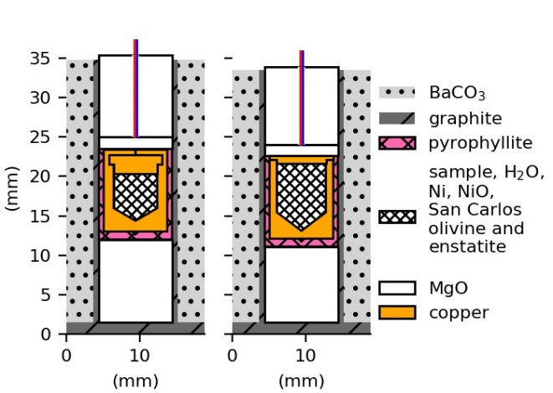

Figure 1. Schematic cross-sections illustrating the experimental design for hydrating San Carlos olivine samples SC1-2 and SC1-7 in a piston cylinder apparatus showing the BaCO3 pressure medium, graphite furnace and pyrophyllite sleeve surrounding an unwelded copper capsule containing the sample, liquid water, and a powdered mixture of nickel, nickel oxide, San Carlos olivine, and San Carlos enstatite. The sleeve and capsule are supported by MgO, and D-type W-Re thermocouples (colored lines) extend through cylindrical holes in the MgO.

## Dehydration

Olivine samples SC1-2 (partially hydrated according to procedure described above) and Kiki (untreated) were dehydrated in increments using the vertical furnace used in previous dehydration experiments (Ferriss 2015), and oxygen fugacity was controlled with a mixture of CO and CO2. SC1-2 was heated at 800 °C for 1, 3, 7, 13, 19, 43, and 68 hours at an oxygen fugacity 10-16.5 bars, equivalent to NNO-2.6, where NNO is the nickel-nickel oxide buffer. Kiki was heated at 800°C for 1 and 8 hours; then 3, 6, 7, and 8 hours at 1000°C. All heating steps for Kiki were conducted at oxygen fugacity of NNO-2.6 except for the final step at 1000°C, which was conducted at relatively oxidizing conditions, NNO+2.

## FTIR and diffusion modeling

Before heat treatment and in between each heating step, samples were analyzed by polarized FTIR along 3 orthogonal traverses parallel to the three crystallographic directions in the uncut crystal. These analyses use the same conditions described above for estimating the initial water and were in all cases conducted with polarized radiation with the electric vector E || [100]. Quadratic baselines were drawn based on the curve of the spectrum of the untreated and/or the dehydrated sample, with typical wavenumber ranges of 3200-3700 cm-1, and the resulting areas were scaled up to approximate hydrogen concentrations by comparison with the corresponding area measured in the same way in the untreated sample, for which hydrogen concentrations are known.

Each profile was normalized to the initial measurements to produce a ratio of the final to initial area A/A0 and scaled up to a true concentration based on the initial concentrations, A0, determined above. These “whole-block” concentrations represent the average concentration through the entire path of the infrared beam, and the forward models used to determine hydrogen diffusivities in each direction are modified accordingly following the models described in E. Ferriss et al. (2015) and Elizabeth Ferriss, Plank, and Walker (2016) and implemented using the free, open-source software package pynams (Ferriss 2015).

To explore possible differences among various hydrogen incorporation mechanisms, the same normalization and fitting procedures were applied to individual peaks using the peak heights relative to the quadratic baseline. Particular emphasis was placed on peaks at the following 4 wavenumbers: 3600 cm-1, which is a [Si] peak with a nearby Fe2+ (Blanchard et al. 2017) that we designate here [Si-Fe2+]; 3525 cm-1, the [Ti] peak for which Padrón-Navarta, Hermann, and O’Neill (2014) report diffusivities in Fe-free synthetic forsterite, here [Ti]; 3356 cm-1, part of a [tri] doublet associated with Fe3+ (Blanchard et al. 2017), here [tri-Fe3+-3356]; and 3236 cm-1, likely a [Mg] peak (Berry et al. 2005).

All of the raw FTIR spectra, baselines, and computer code used to produce all calculations and figures reported in this paper will be made available on GitHub.

# Results

## Characterization of the starting material

Microprobe analysis did not reveal any significant zonation along the measured profiles and were generally consistent with previous work (Ruprecht and Plank 2013; Ferguson et al. 2016) with somewhat lower forsterite numbers: 87.7±0.2 in SC1-2 and 86.2±0.2 in Kiki.

The initial water concentration was estimated from the polarized FTIR measurements and baselines shown in Figure 2 using both the Bell calibration and the Withers calibration and also by nanoSIMS (Table 1). These three estimates were averaged to produce initial water concentration estimates of 15±2 ppm H2O in the Kilauea Iki olivine and 4±1 ppm H2O in the San Carlos olivine. These low concentrations are consistent with previous work on San Carlos olivine (Peslier and Luhr 2006; Kurosawa, Yurimoto, and Sueno 1997)**.** The hydrogen concentration in the Kilauea Iki sample, for which the rims had been polished off to prepare the sample as a rectangular parallelepiped, was homogeneous by both SIMS and FTIR.

Several different O-H peaks were observed in the initial materials. The prominent peaks at wavenumbers 3525 and 3573 cm-1 oriented primarily || [100] in both Kilauea Iki and San Carlos olivine correspond to the [Ti] incorporation mechanism, and the high-wavenumber peaks that primarily appear as shoulders on the [Ti] peaks correspond to the [Si] mechanism (Berry et al. 2005). A very small peak at 3600 cm-1 present in both samples has been ascribed to [Si] with nearby Fe2+ (Blanchard et al. 2017). Because of the association with Fe2+, we label this peak [Si-Fe2+]. The Kilauea Iki olivine, but not the untreated San Carlos olivine, contains prominent [tri] peaks. These peaks at 3356 and 3329 cm-1 correspond exactly to the peak locations that Blanchard et al. (2017) associate with Fe3+, and which we therefore designate.

## 

Figure 2. Polarized FTIR spectra (thick blue) and baselines (black) used to estimate the water concentrations of Kilauea Iki olivine (Kiki) and San Carlos olivine (SC1-1 and SC1-2) reported in Table 1.

Table 1. Water concentration estimates for Kilauea Iki olivine and San Carlos olivine based on polarized FTIR areas (Figure 2 and Figure 3) and SIMS measurements.

|  |  |  |  |
| --- | --- | --- | --- |
|  | Kilauea Iki olivine; Kiki | San Carlos olivine; sub-samples of SC1 | |
| FTIR area E || [100] (cm-2) | 52+/-10 | 7+/-5  55+/-17  24+/-8  7+/-6 | untreated SC1-1  partially hydrated SC1-7  partially hydrated SC1-2  dehydrated SC1-2 |
| FTIR area E || [010] (cm-2) | 31+/-13 | 8+/-5 | untreated SC1-1 |
| FTIR area E || [001] (cm-2) | 18+/-9 | 9+/-4 | untreated SC1-1 |
| FTIR area summed over 3 directions (cm-2) | 101+/-19 | 24+/-8 | untreated SC1-1 |
| Water, Bell calibration (ppm H2O) | 19+/-4 | 4.5+/-1.5 | untreated SC1-1 |
| Water, Withers calibration (ppm H2O) | 12+/-2 | 3+/-1 | untreated SC1-1 |
| Water, SIMS (ppm H2O) | 14+/-1 | 5+/1 | dehydrated SC1-2 |
| Average initial water (ppm H2O) | 15+/-2 | 4+/-1 | SC1 |
| Ratio of water in ppm H2O to area in cm-2 with E || [100] | 0.3 | 0.6 | SC1-1 |
| Average water (ppm H2O) after piston cylinder experiment | Not treated with pressure | 32+/-23  14+/-10 | partially hydrated SC1-7  partially hydrated SC1-2 |

## Hydration

Changes in FTIR absorbance indicate that hydrogen was successfully incorporated into San Carlos olivine samples SC1-7 and SC1-2 (Figure 3A). To construct hydrogen profiles, quadratic baselines (Figure 3B and C) were drawn to match both the curve of the spectrum of the untreated sample and the middle baselines used to determine the initial water concentration in Figure 2. The area under each curve was determined and scaled to an estimated H concentration by multiplying by 0.6, following the ratio of concentration to area with E || [100] reported for San Carlos olivine in Table 1.

The partially hydrated sample SC1-2 was sufficiently homogeneous for both bulk H and individual peaks to serve as a reasonable starting material for subsequent dehydration experiments (Figure 4). If we ignore the uncertainties associated with baseline choice and use only the quadratic baseline shown in Figure 3C, the water concentration across hydrated SC1-2 is 15±1 ppm H2O. Although there is a small increase in area around the [tri] peaks, the large majority of the hydrogen in the hydrated SC1-2 is incorporated as [Ti] and [Si], and these profiles are also homogeneous.

In contrast, hydrogen zonation in SC1-7 is clearly observed, with water concentrations of 38±7 ppm H2O using the quadratic baseline shown in Figure 3B. The variations in concentration are most apparent || [001], consistent with previously work showing c as fast direction during proton-vacancy mechanism diffusion (Kohlstedt and Mackwell 1998; Demouchy and Mackwell 2006).

Quantifying the diffusivities is SC1-7 requires major assumptions about both the solubility and ‘metastable equilibrium’ concentrations. The estimated concentration of 58 ppm H2O on the edge of SC1-7 is much lower than the expected final solubility of around 112 ppm H2O (Mosenfelder et al. 2006), and the ‘metastable equilibrium’ concentration of 15±1 ppm H2O is much higher than the 0.4 ppm H2O (7 H/106Si) reported by Kohlstedt and Mackwell (1998). Kohlstedt and Mackwell (1998) also report a final concentration of only 3 ppm H2O (50 H/106Si), suggesting that the scaling factor used is significantly different among studies. If Kohlstedt and Mackwell (1998)’s final concentration is assumed to be 112 ppm H2O, then the scaled-up “metastable equilibrium” concentration would be 16 ppm H2O, very close to what is observed in SC1-2. Path-integrated 3D diffusion modeling that assumes an initial “metastable equilibrium” concentration of 15 ppm H2O, a final solubility concentration of 112 ppm H2O, and the diffusivities expected at 1000°C for the proton-vacancy diffusion mechanism (Kohlstedt and Mackwell 1998) provides a reasonably close match to the measured data for bulk H and the [Ti] peak (Figure 4). The [Si-Fe2+] peak is somewhat slower, and the [tri-Fe3+-3356] and [Mg] peaks are somewhat faster. Least-squares fitting to the data without any constraints often gave results that varied by several orders of magnitude in a given direction from one set of profile to another and typically had very large errors, so to get more quantitative sense of the difference in diffusivities, we held all variables constant like those shown in Figure 4 and then allowed only the diffusivity || c to vary (Figure 4 orange lines). The resulting diffusivities || c are as follows: 10-13.1±2.2 m2/s for bulk H, 10-13.5 ± 21.2 m2/s for [Si-Fe2+], 10-13.3 ± 5.9 m2/s for [Ti], 10-13.0 ± 2.1 m2/s for [tri-Fe3+-3356], and 10-12.7 ± 1.1 m2/s for [Mg]. These differences in diffusivities are in general agreement with the observation that [Si] diffuses more slowly than [Ti], which diffuses more slowly than [Mg] in forsterite (Padrón-Navarta, Hermann, and O’Neill 2014), although the exact valus are not in perfect agreement (Figure 5).

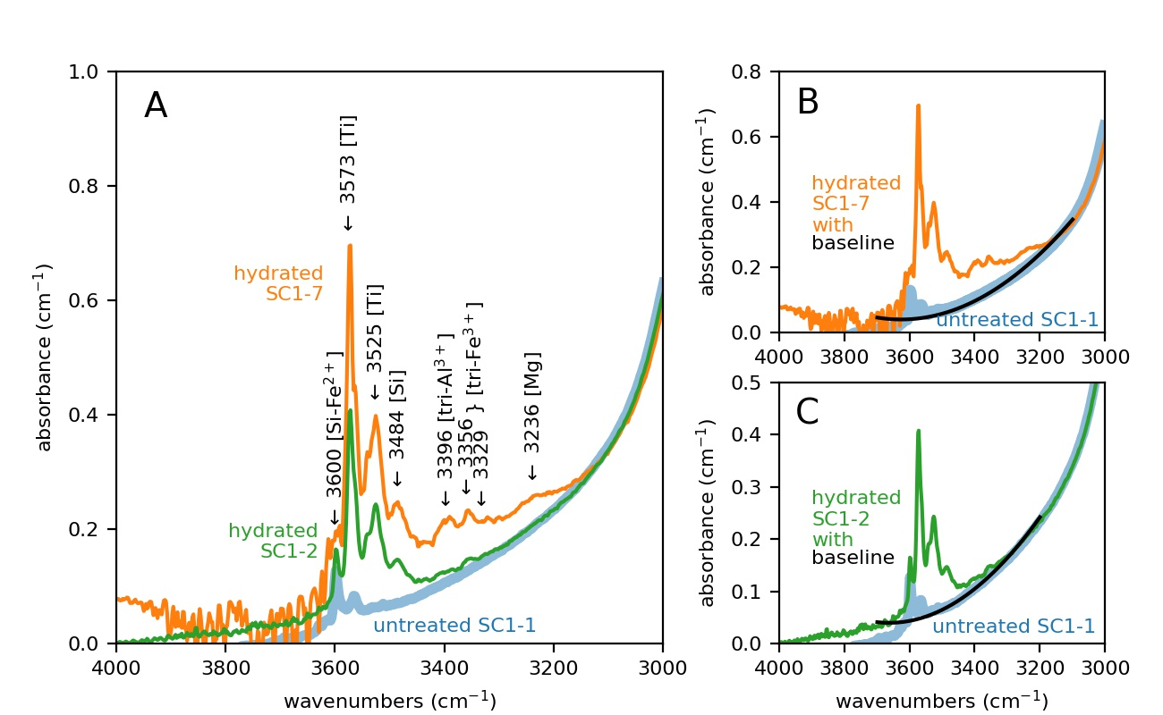

Figure 3. (A) Polarized FTIR spectra with electric vector E || [100] averaged across all traverses in three directions of San Carlos olivine SC1 pieces that were untreated (SC1-1, blue); hydrated in a piston cylinder for exactly the amount of time needed to reach “metastable equilibrium” by the proton-polaron mechanism (SC1-2, green) at 800°C; and hydrated long enough to enter into proton-vacancy-dominated diffusion without saturating the sample (SC1-7, orange) with major peaks labeled. The shapes of the quadratic baselines used to calculate the areas under each curve for spectra measured are shown for SC1-7 (B) and SC1-2 (C). Note the differences in the y-axis scale.

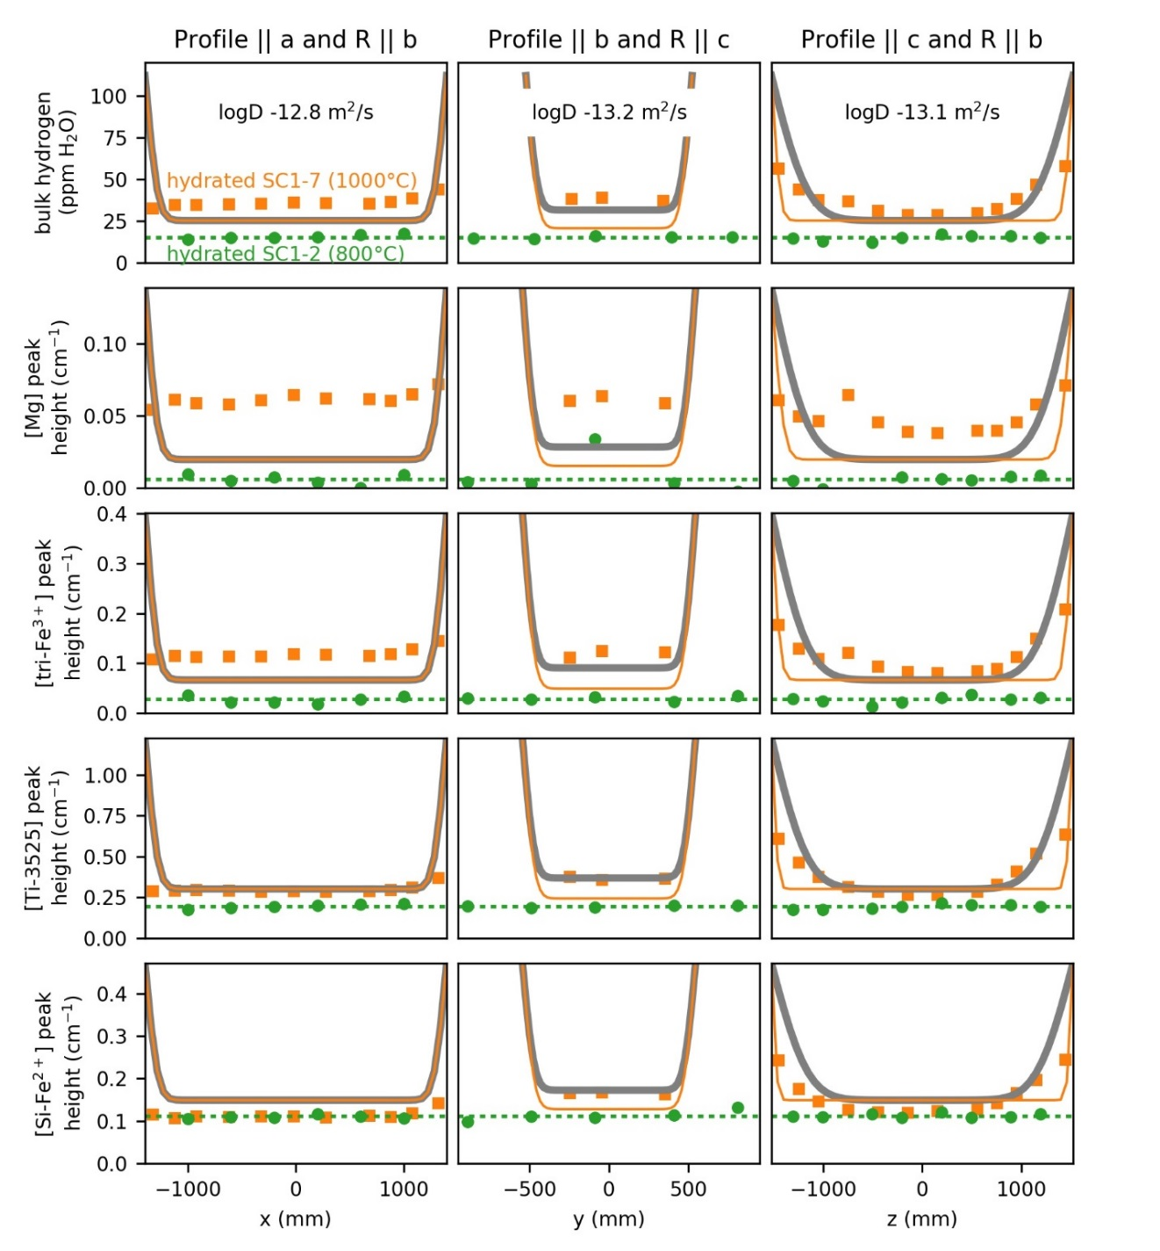

Figure 4. Concentration profiles across San Carlos olivine samples SC1-2 (green circles) and SC1-7 (orange squares) after partial hydration in a piston cylinder as measured through the uncut block. R is the ray path of the infrared beam, and the electric vector E of the polarized infrared beam is in all cases || a. Hydrogen concentrations are estimated from polarized FTIR spectra based using the areas under the baselines shown in Figure 3 and initial hydrogen contents from Table 1. Profiles constructed with alternative baselines are provided in Supplementary Figure 2 and Supplementary Figure 3. Grey curves show the expected diffusion curves based on the diffusivities (D) for proton-vacancy mechanism diffusion at 1000°C, an initial “metastable equilibrium” concentration equal to the mean concentration or peak height in the hydrated SC1-2 (dotted green lines) and final concentration equal to the expected solubility of 112 ppm H2O. Thin orange lines show least-squares best-fit diffusivities under the same conditions when the diffusivity || c, but not || to a or b, is allowed to change.

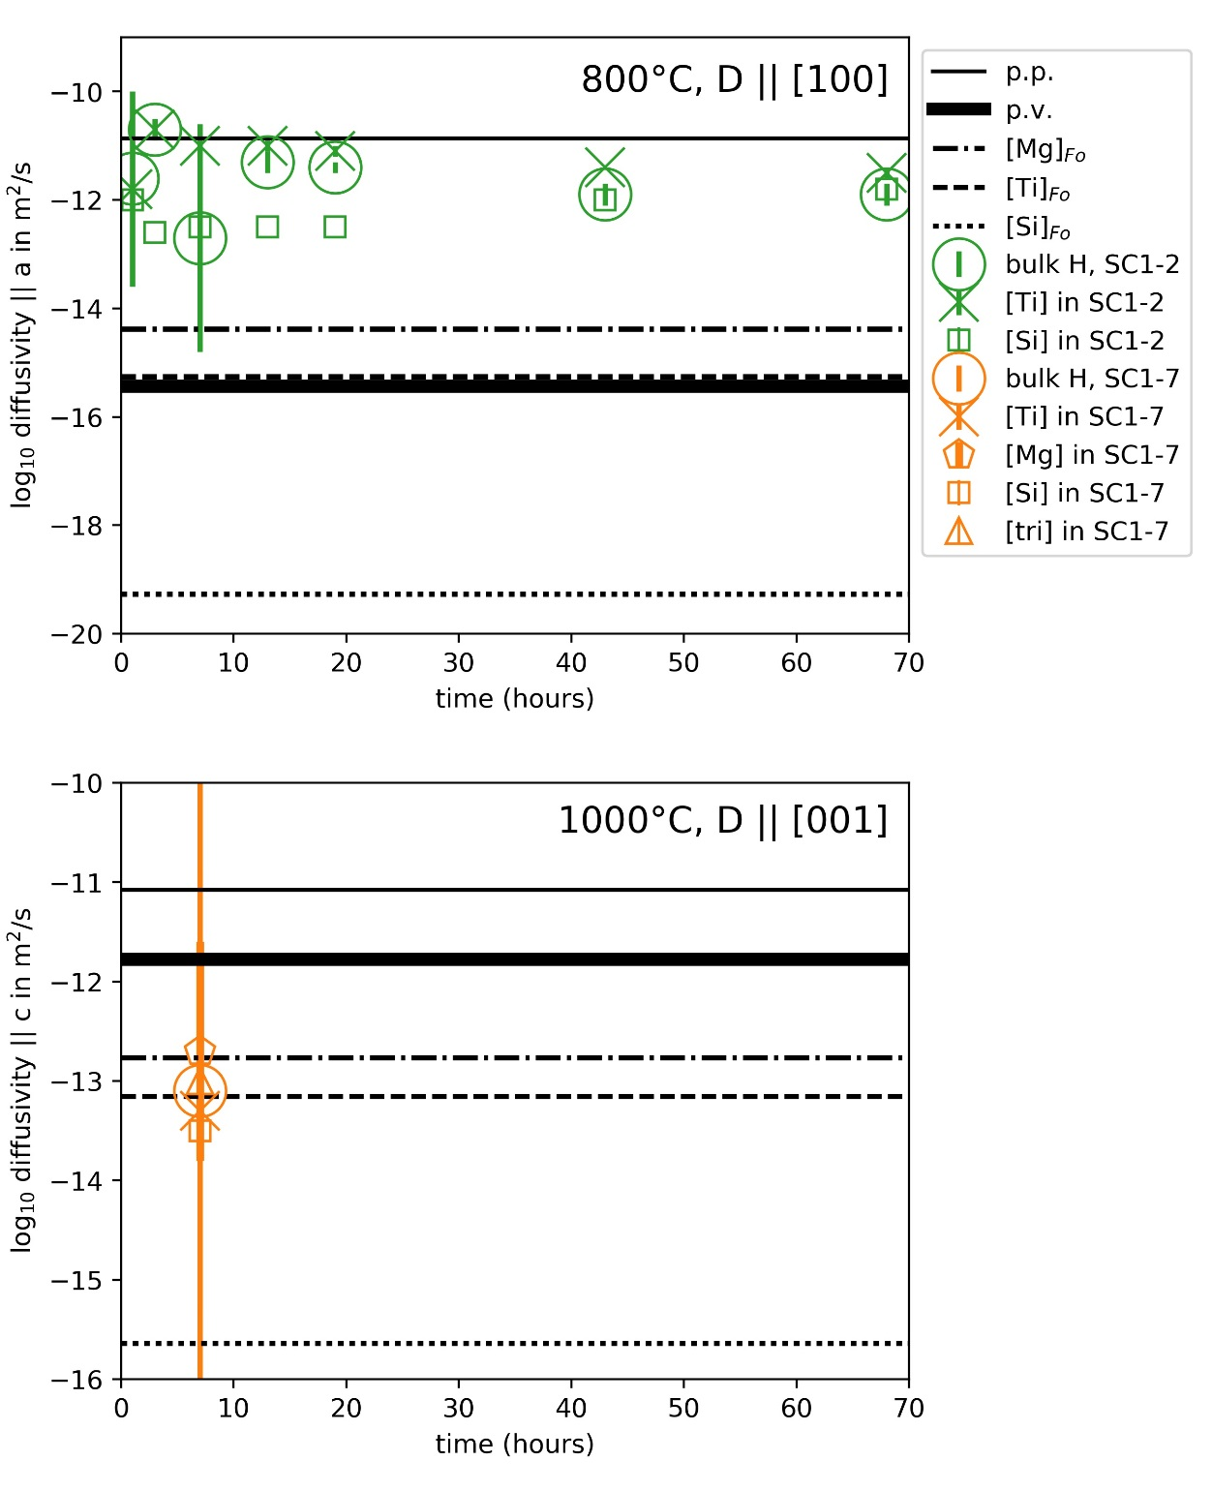

Figure . Diffusivities (D) determined at two different temperatures, 800 and 1000°C, during hydration of San Carlos olivine SC1-7 primarily by the proton-vacancy or “p.v” mechanism at 1000°C, dehydration of San Carlos olivine SC1-2 after partial hydration by the proton-polaron or “p.p” mechanism at 800°C, and dehydration of Kilauea Iki olivine Kiki first at 800°C and then 1000°C (**COMING SOON**) compared with expected diffusivities for bulk H (Kohlstedt and Mackwell 1998) and peak-specific H incorporation mechanisms [Ti], [Mg], [Si], and [tri] in unoriented synthetic forsterite (Fo) (Padrón-Navarta, Hermann, and O’Neill 2014). Note diffusivities || [100], the fast direction in the p.p., are plotted in the 800°C panel, and diffusivities || [001], the fast direction in p.v., are plotted in the 1000°C panel. **I NEED TO PUT ALL THIS DATA IN A TABLE.**

## Dehydration

SC1-2 and Kiki, two homogeneous blocks of olivine with similar initial starting hydrogen concentrations but very different histories and compositions and distributions of hydrogen, were sequentially dehydrated in a gas-mixing furnace (Figure 6). Quadratic baselines were used to construct water loss profiles (Figure 7, **FIGURE 8 to come**). These profiles were normalized to the initial hydrated concentrations. Several of the profiles are assymetric, which we attribute primarily to error in the quadratic baselines used. Linear baselines drawn between wavenumbers 3700 and 3200 cm-1 remove much of this asymmetry (Supplementary Figure 4) but could in some cases result in negative areas, particularly during the final dehydration steps and near edges (Supplementary Figure 5). Path-integrated 3-dimensional diffusion modeling was performed to estimate the rate of hydrogen movement for each time step in SC1-2 (Supplementary Figure 6 through Supplementary Figure 12) and Kiki (**COMING SOON**), and the results are shown in Figure 5.

The dominant peaks in the partially hydrated SC1-2 used as a starting material for dehydration are [Ti] and [Si]. We estimate diffusivities for [Si-Fe2+] at 3600 cm-1 and [Ti-3525]. The other [Ti] peak and [Si] peaks profiles in SC1-2 are similar to [Ti-3525]. [Mg] peaks were not observed in SC1-2. Some disordered [tri] peaks were occasionally observed near the edge (Supplementary Figure 5), but these were so uncommon that they are difficult to model **[I should really go look at these in more detail]**.

Dehydration of the Kilauea Iki sample took place in multiple stages. During dehydration of the Kilauea Iki sample at 800°C, clear profiles could be distinguished for [tri-Fe3+-3356] as well as the two peaks [Ti-3525] and [Si-Fe2+] discussed for SC1-2. **Model, model, pants on foddle!** 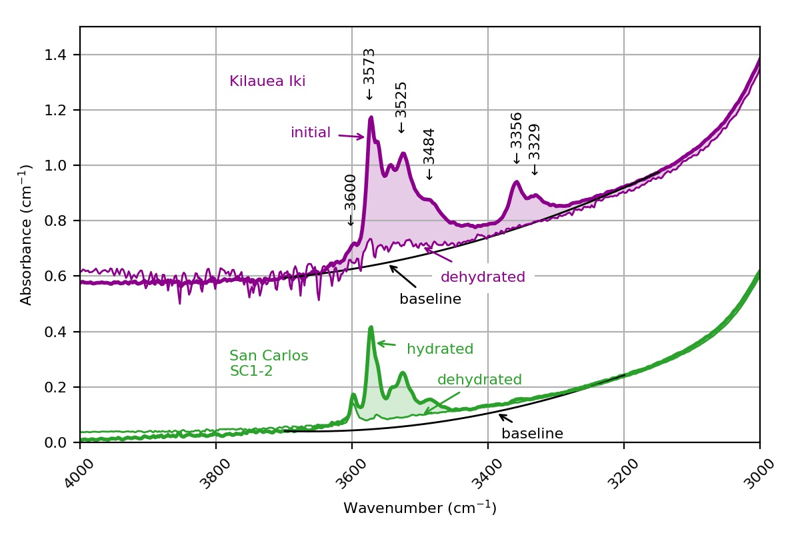

Figure 6. Averaged polarized FTIR spectra with electric vector E || [100] of untreated Kilauea Iki olivine Kiki (offset for clarity) and partially hydrated San Carlos olivine SC1-2. Both samples contain around 15 ppm H2O (Table 1), but the hydrogen is incorporated into the structures in different ways, resulting in different peak locations and absorbances || [100]. Quadratic baselines like those shown in black were used to construct hydrogen loss profiles.

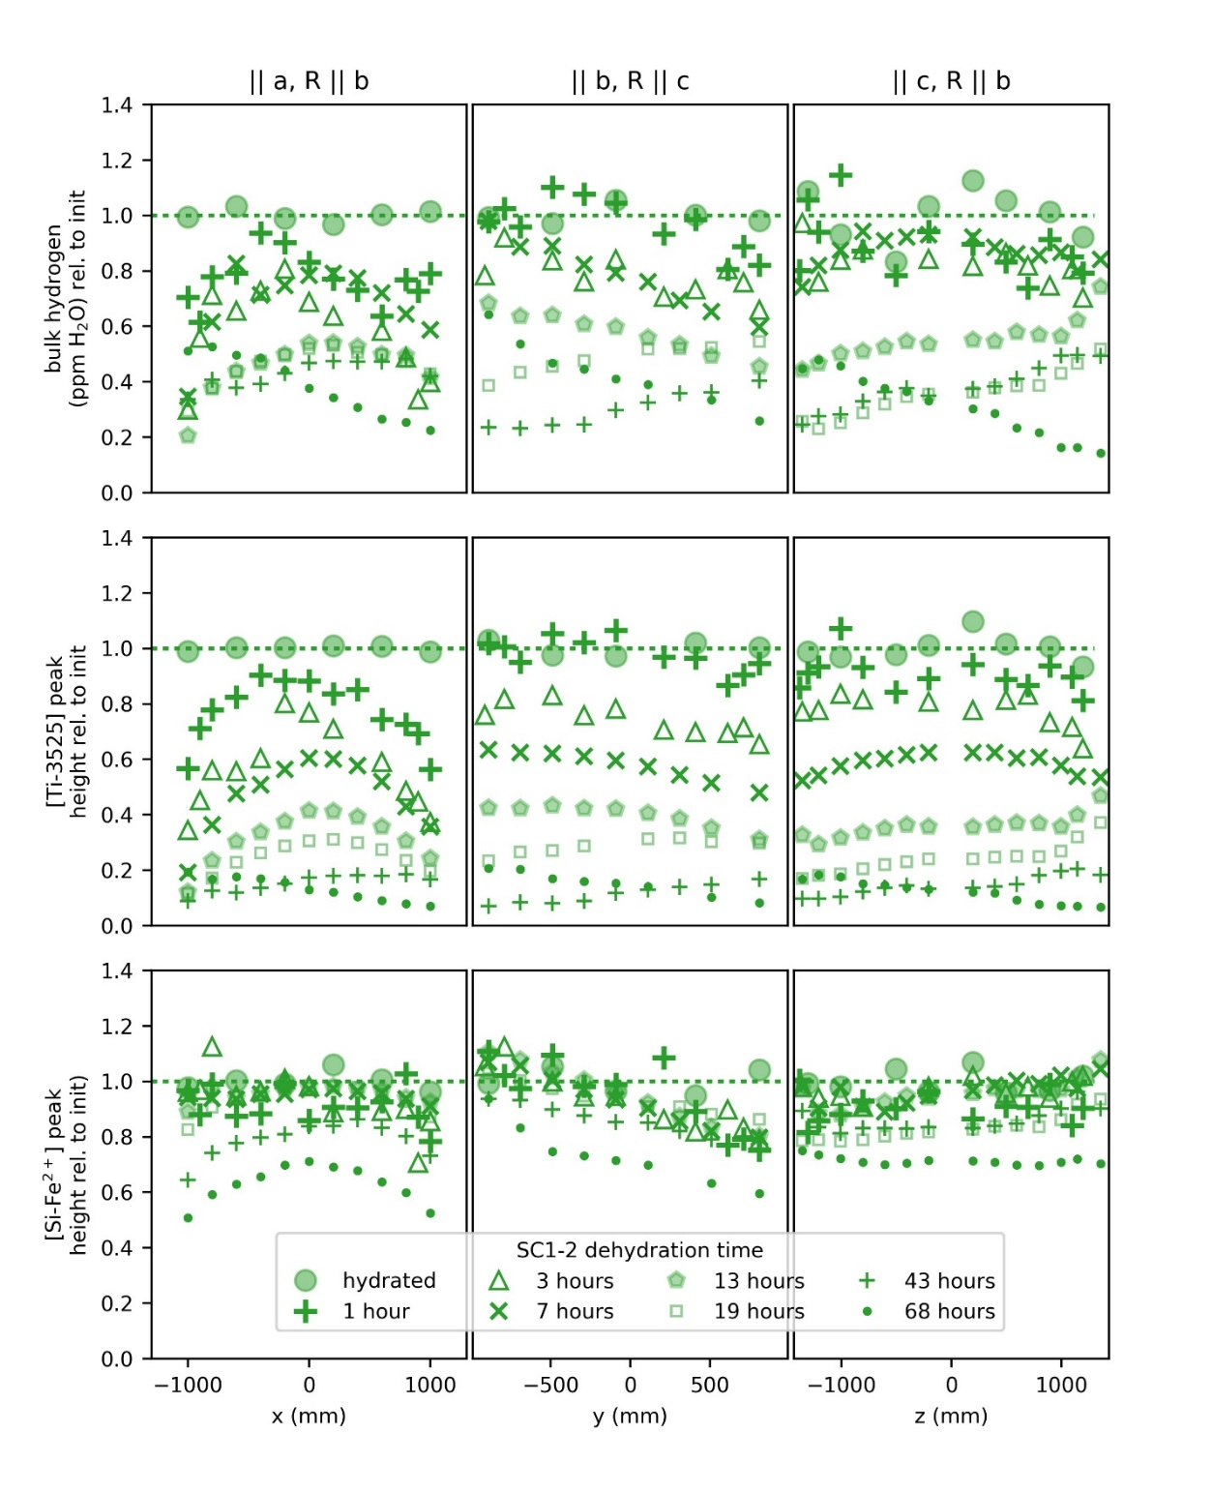

Figure 7. Profiles of bulk H (top) and two peaks during step-wise dehydration of partially hydrated San Carlos olivine SC1-2 at 1 atm, 800°C, and QFM-2. The bulk H is scaled assuming that the hydrated sample contained 14 ppm H2O (Table 1), and all profiles are normalized relative to the hydrated profile to account for small amounts of initial zonation. We attribute the assymetry in some of the profiles primarily to differences between the baselines used to determine these areas (Figure 6) and the true baselines, which could not be easily determined and also appeared to change over time.

# Supplementary Figures

# 

1. Additional hydration profiles using the same quadratic baselines used for the hydration profiles in Figure 4. Hydration profiles from Figure 4 are included for comparison.

# 

1. Hydration profiles generated using linear baselines.

# 

1. Hydration profiles generated using quadratic baselines that are more generous than those shown in Figure 3.

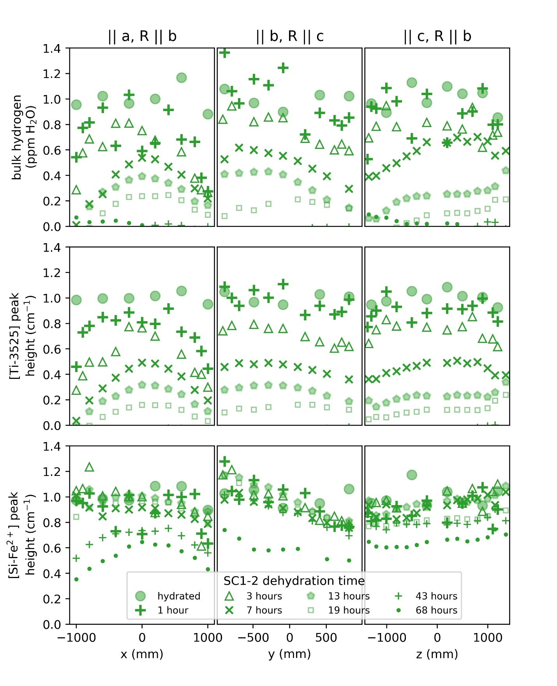

1. Dehydration profiles for SC1-2 shown in Figure 7 generated using linear baselines like those shown in Figure 2. These linear baselines produce more symmetric profiles than the quadratic baselines used for modeling but often result in negative areas for spectra measured after the final two dehydration steps.

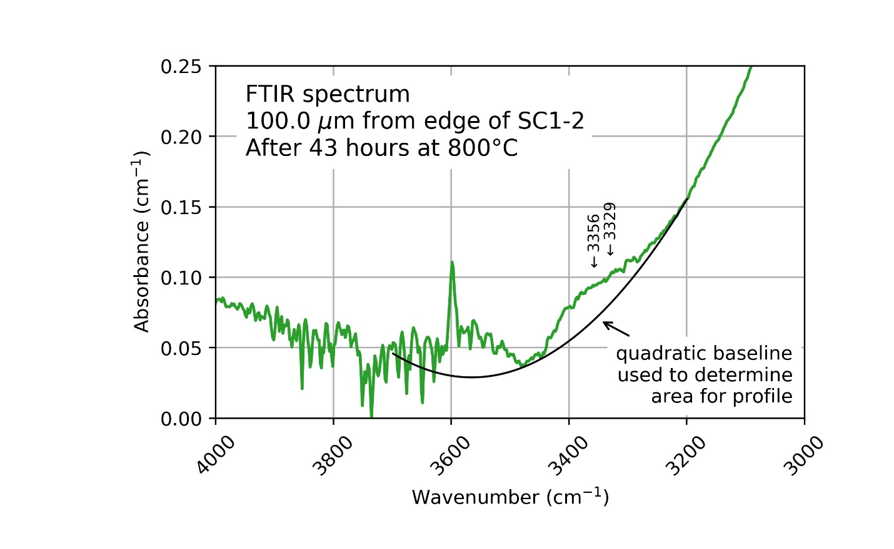

1. One example of an FTIR spectrum measured near the edge of San Carlos olivine SC1-2 for which [tri] peaks (labeled) are observed and the baseline is strongly curved.

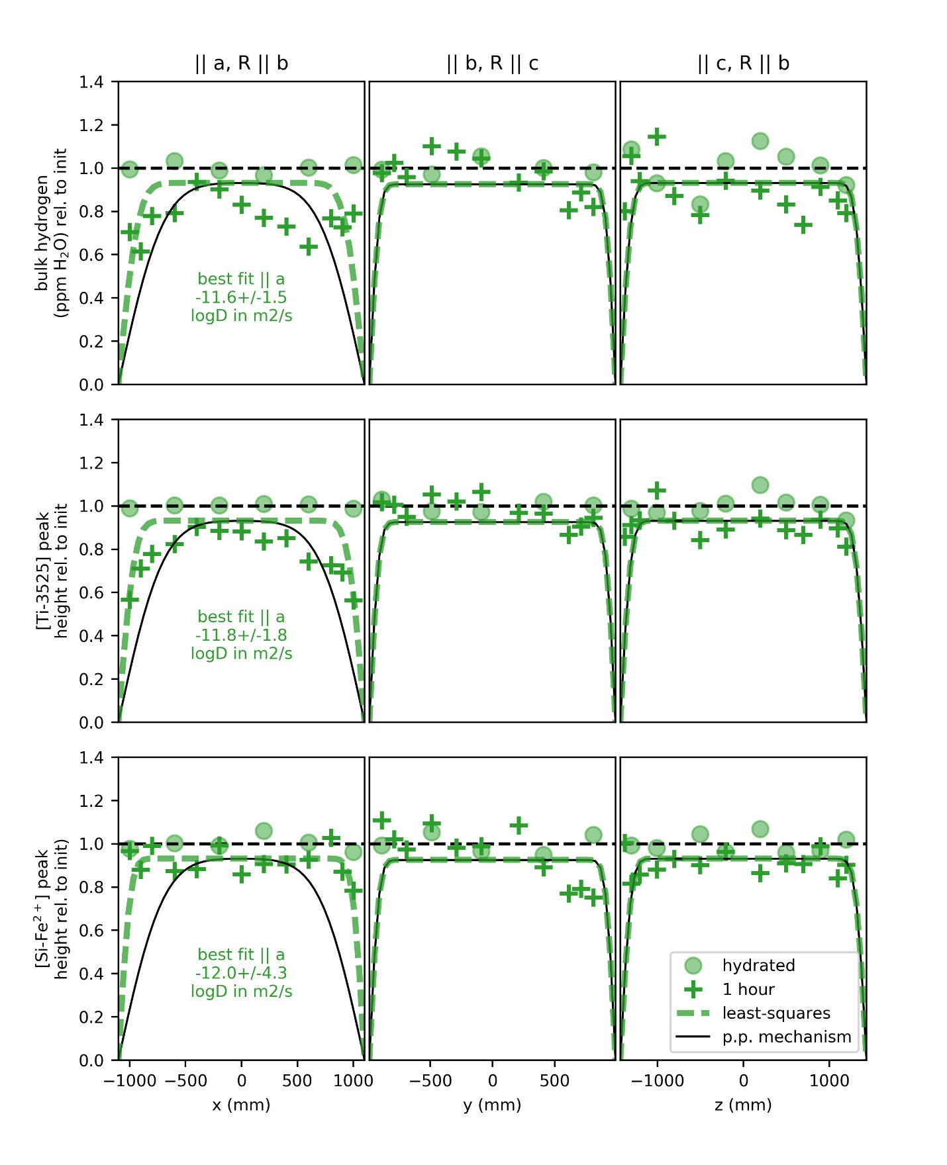

1. Measured dehydration curves in the uncut San Carlos olivine SC1-2 after the first heating step shown in Figure 7 and modeled diffusion curves. The black ‘p.p.’ curves show the expected profiles if diffusion proceeds according to the proton-polaron mechanism as described by Kohlstedt and Mackwell (1998). The dashed green curves show the least-squares best-fit diffusion curves when the diffusivity was allowed to deviate from p.p. || [100].

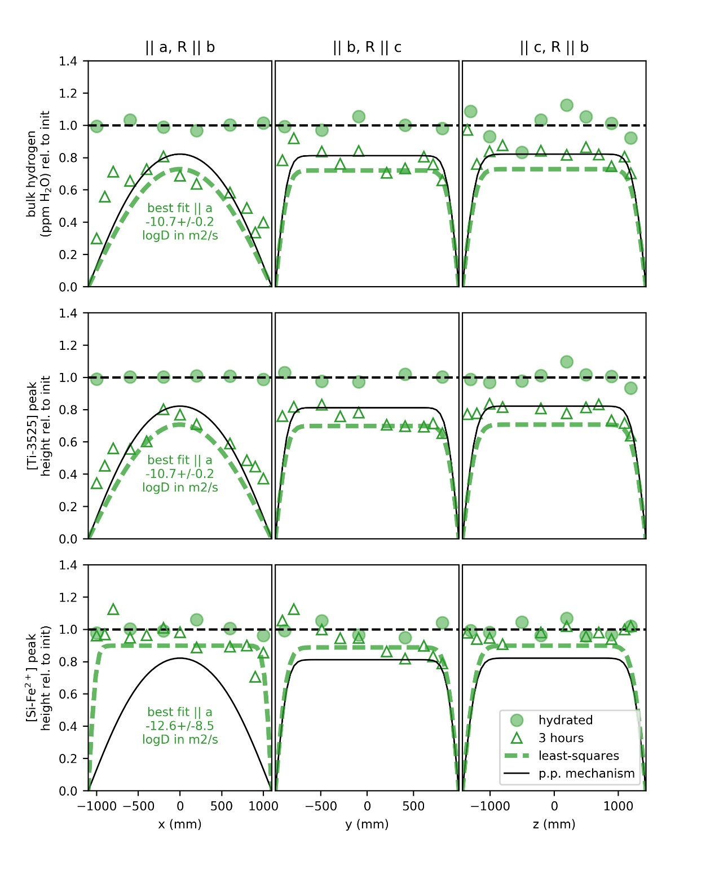

1. Measured dehydration curves in the uncut San Carlos olivine SC1-2 after the second heating step shown in Figure 7 and modeled diffusion curves. The black ‘p.p.’ curves show the expected profiles if diffusion proceeds according to the proton-polaron mechanism as described by Kohlstedt and Mackwell (1998). The dashed green curves show the least-squares best-fit diffusion curves when the diffusivity was allowed to deviate from p.p. || [100].

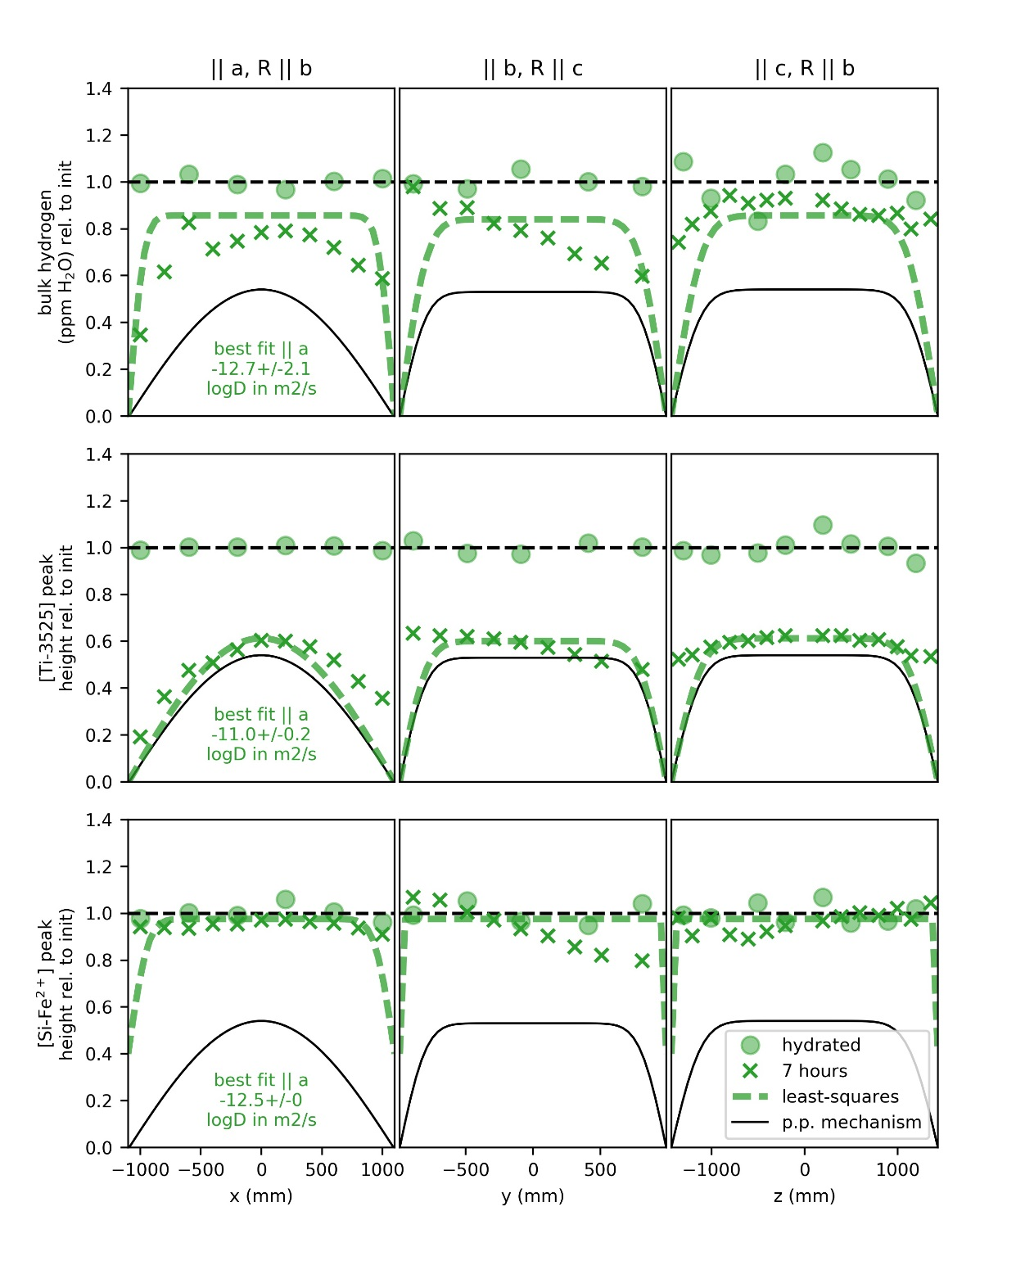

1. Measured dehydration curves in the uncut San Carlos olivine SC1-2 after the third heating step shown in Figure 7 and modeled diffusion curves. The black ‘p.p.’ curves show the expected profiles if diffusion proceeds according to the proton-polaron mechanism as described by Kohlstedt and Mackwell (1998). The dashed green curves show the least-squares best-fit diffusion curves when the diffusivity was allowed to deviate from p.p. || [100] for bulk H and [Ti]. The best-fit curve shown for [Si] is a maximum estimate assuming a final [Si] level of 0.4 times the initial hydrated state.

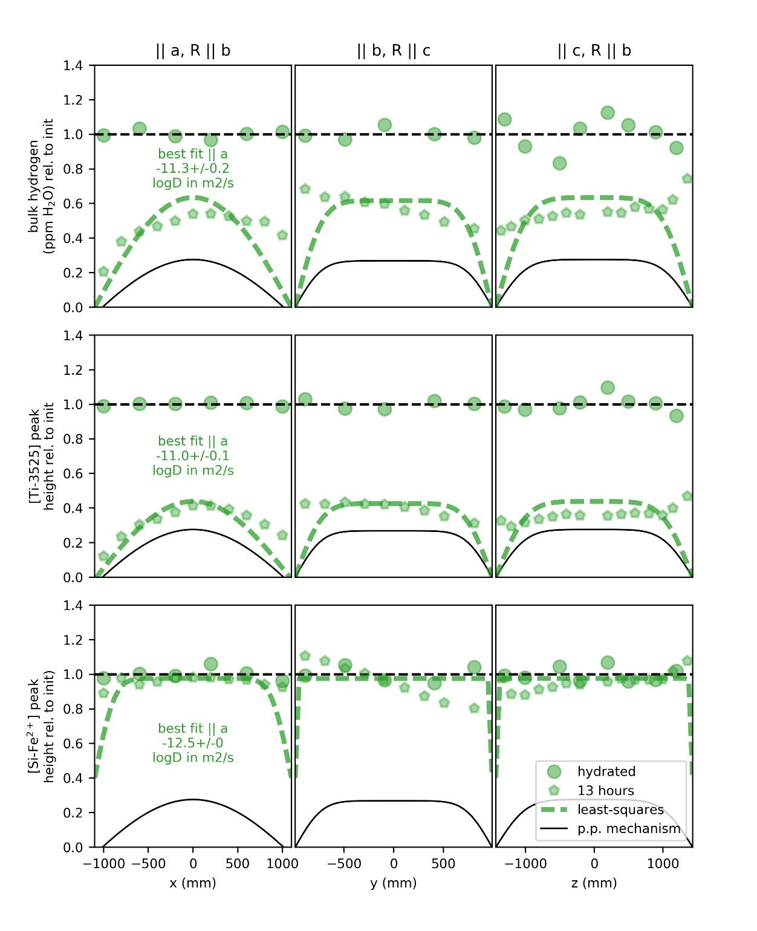

1. Measured dehydration curves in the uncut San Carlos olivine SC1-2 after the fourth heating step shown in Figure 7 and modeled diffusion curves. The black ‘p.p.’ curves show the expected profiles if diffusion proceeds according to the proton-polaron mechanism as described by Kohlstedt and Mackwell (1998). The dashed green curves show the least-squares best-fit diffusion curves when the diffusivity was allowed to deviate from p.p. || [100] for bulk H and [Ti]. The best-fit curve shown for [Si] is a maximum estimate assuming a final [Si] level of 0.4 times the initial hydrated state.

+

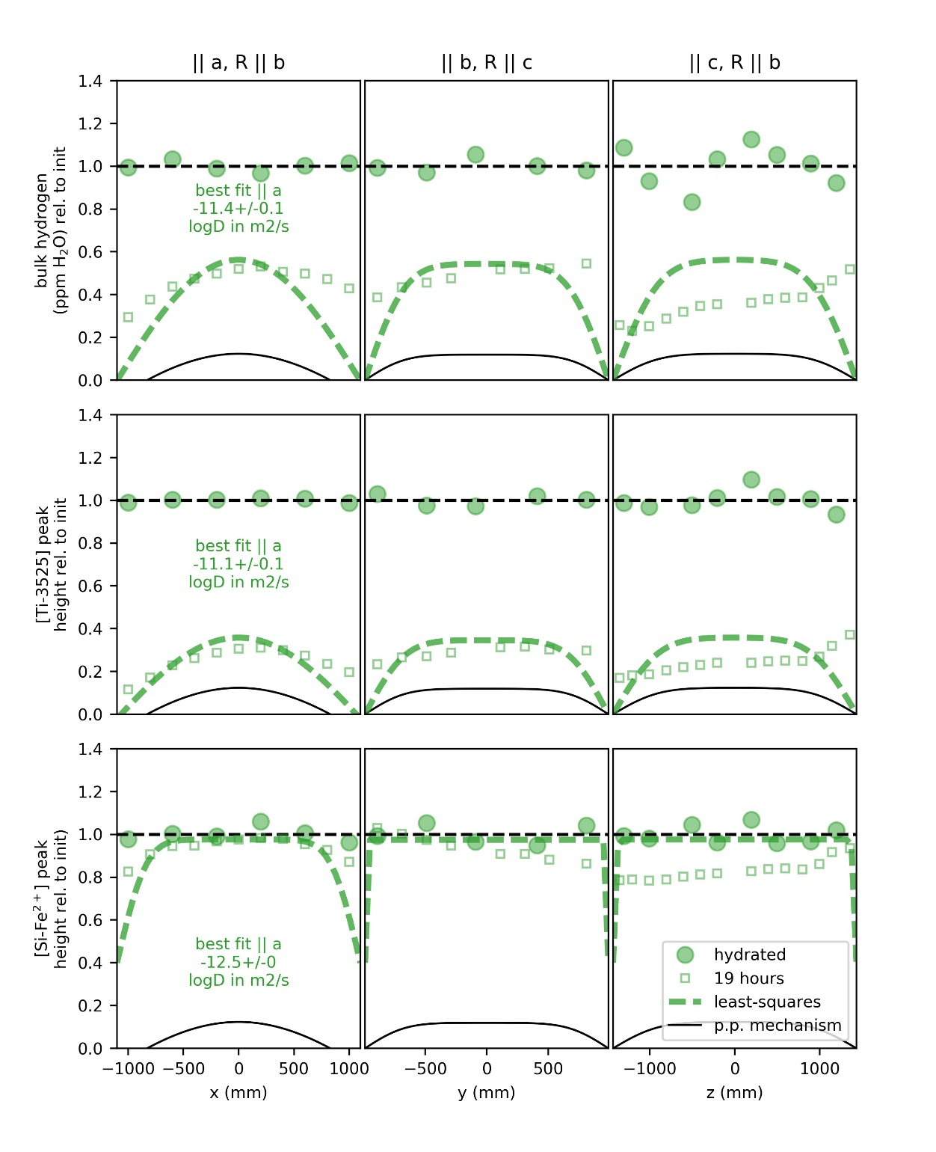

1. Measured dehydration curves in the uncut San Carlos olivine SC1-2 after the fifth heating step shown in Figure 7 and modeled diffusion curves. The black ‘p.p.’ curves show the expected profiles if diffusion proceeds according to the proton-polaron mechanism as described by Kohlstedt and Mackwell (1998). The dashed green curves show the least-squares best-fit diffusion curves when the diffusivity was allowed to deviate from p.p. || [100] for bulk H and [Ti]. The best-fit curve shown for [Si] is a maximum estimate assuming a final [Si] level of 0.4 times the initial hydrated state and a fast direction || [100].

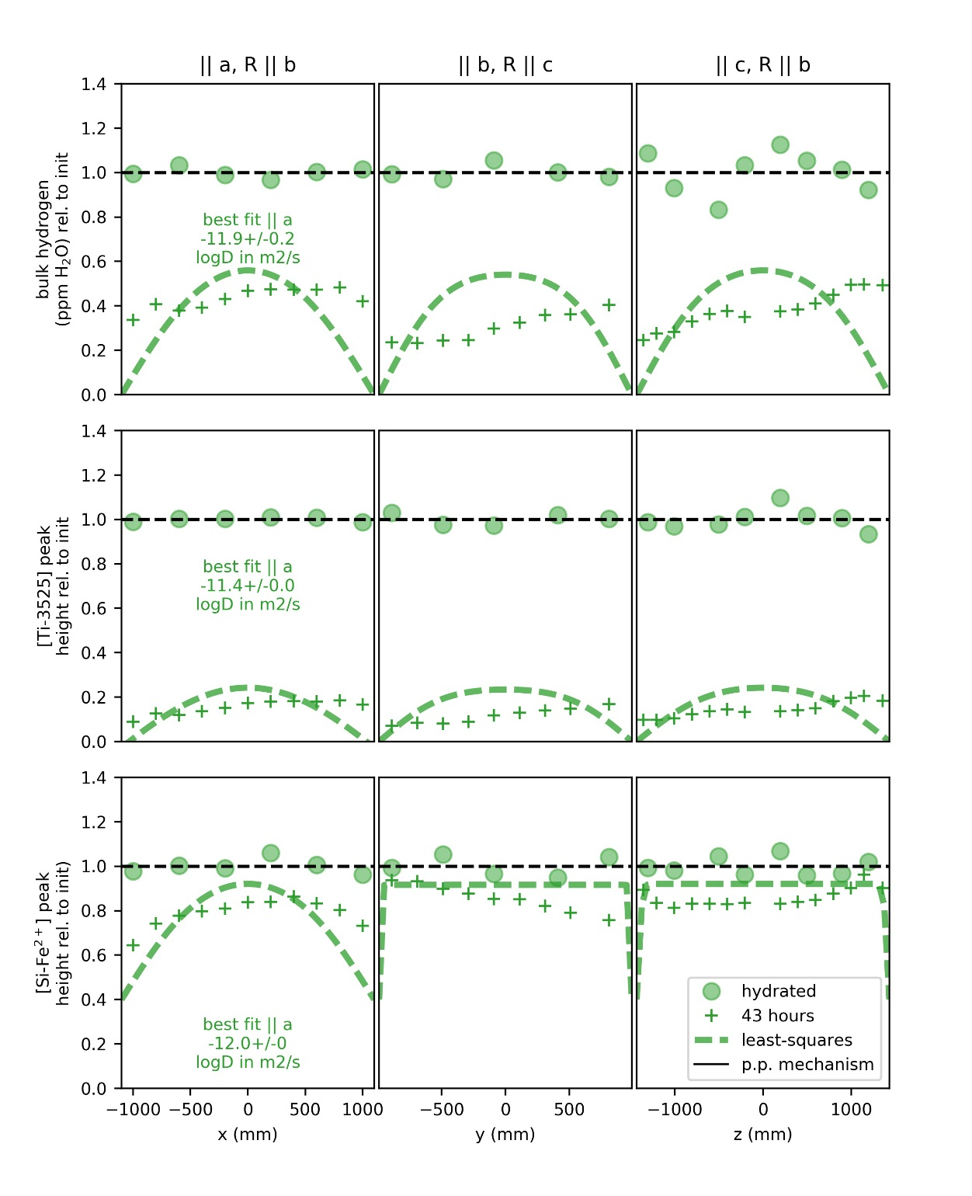

1. Measured dehydration curves in the uncut San Carlos olivine SC1-2 after the sixth heating step shown in Figure 7 and modeled diffusion curves. Diffusion taking place entirely by the proton-polaron ‘p.p.’ mechanism as described by Kohlstedt and Mackwell (1998) would result in zero remaining H at this stage. The dashed green curves show the least-squares best-fit diffusion curves when the diffusivity was allowed to deviate from p.p. || [100] for bulk H and [Ti]. The best-fit curve shown for [Si] is a maximum estimate assuming a final [Si] level of 0.4 times the initial hydrated state and a fast direction || [100].

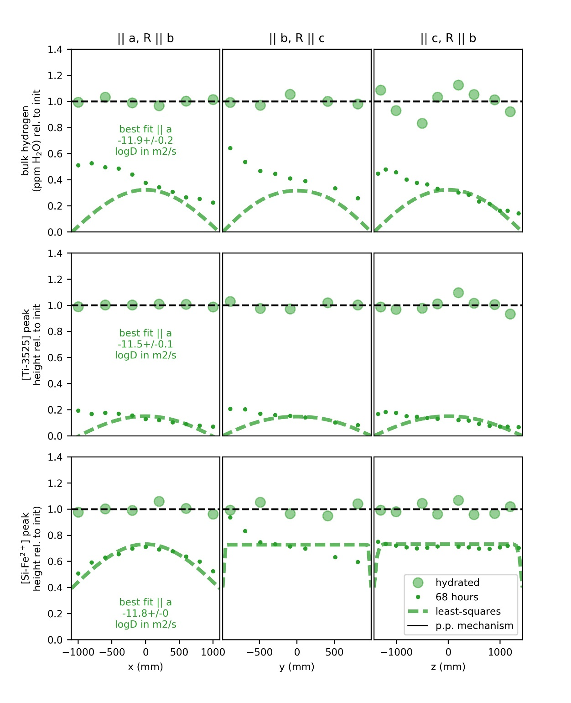

1. Measured dehydration curves in the uncut San Carlos olivine SC1-2 after the seventh and final heating step shown in Figure 7 and modeled diffusion curves. Diffusion taking place entirely by the proton-polaron ‘p.p.’ mechanism as described by Kohlstedt and Mackwell (1998) would result in zero remaining H at this stage. The dashed green curves show the least-squares best-fit diffusion curves when the diffusivity was allowed to deviate from p.p. || [100] for bulk H and [Ti]. The best-fit curve shown for [Si] is a maximum estimate assuming a final [Si] level of 0.4 times the initial hydrated state and a fast direction || [100].

# Bibliography

Bell, D. R., and G. R. Rossman  
 1992 Water in Earth’s Mantle: The Role of Nominally Anhydrous Minerals. Science 255(5050). WOS:A1992HH74400043: 1391–1397.

Bell, D. R., G. R. Rossman, J. Maldener, D. Endisch, and F. Rauch  
 2003 Hydroxide in Olivine: A Quantitative Determination of the Absolute Amount and Calibration of the IR Spectrum. Journal of Geophysical Research-Solid Earth 108(B2). WOS:000181985400002. ://WOS:000181985400002.

Berry, A. J., J. Hermann, H. S. C. O’Neill, and G. J. Foran  
 2005 Fingerprinting the Water Site in Mantle Olivine. Geology 33(11). WOS:000233059000008: 869–872.

Blanchard, Marc, Jannick Ingrin, Etienne Balan, István Kovács, and Anthony C. Withers  
 2017 Effect of Iron and Trivalent Cations on OH Defects in Olivine. American Mineralogist 102(2): 302–311.

Demouchy, S., and S. Mackwell  
 2006 Mechanisms of Hydrogen Incorporation and Diffusion in Iron-Bearing Olivine. Physics and Chemistry of Minerals 33(5). WOS:000240439000005: 347–355.

Ferguson, David J., Helge M. Gonnermann, Philipp Ruprecht, et al.  
 2016 Magma Decompression Rates during Explosive Eruptions of Kīlauea Volcano, Hawaii, Recorded by Melt Embayments. Bulletin of Volcanology 78(10): 71.

Ferriss, E.  
 2015 Pynams: A Python Package for Interpreting FTIR Spectra of Nominally Anhydrous Minerals (NAMs). New York. https://github.com/EFerriss/pynams.

Ferriss, E., T. Plank, D. Walker, and M. Nettles  
 2015 The Whole-Block Approach to Measuring Hydrogen Diffusivity in Nominally Anhydrous Minerals. American Mineralogist 100(4). WOS:000352175700017: 837–851.

Ferriss, Elizabeth, Terry Plank, and David Walker  
 2016 Site-Specific Hydrogen Diffusion Rates during Clinopyroxene Dehydration. Contributions to Mineralogy and Petrology 171(6): 1–24.

Jollands, Michael C., José Alberto Padrón-Navarta, Jörg Hermann, and Hugh St.C. O’Neill  
 2016 Hydrogen Diffusion in Ti-Doped Forsterite and the Preservation of Metastable Point Defects. American Mineralogist 101(7): 1560–1570.

Keppler, Hans, and Joseph R. Smyth  
 2006 Water in Nominally Anhydrous Minerals, vol.62. Reviews in Mineralogy and Geochemistry. Mineralogical Society of America.

Kohlstedt, D. L., and S. J. Mackwell  
 1998 Diffusion of Hydrogen and Intrinsic Point Defects in Olivine. Zeitschrift Fur Physikalische Chemie-International Journal of Research in Physical Chemistry & Chemical Physics 207. WOS:000076569300010: 147–162.

Kurosawa, M., H. Yurimoto, and S. Sueno  
 1997 Patterns in the Hydrogen and Trace Element Compositions of Mantle Olivines. Physics and Chemistry of Glasses 24: 385–395.

Libowitzky, E., and G. R. Rossman  
 1996 Principles of Quantitative Absorbance Measurements in Anisotropic Crystals. Physics and Chemistry of Minerals 23(6). WOS:A1996VD85000001: 319–327.

Mackwell, S. J., and D. L. Kohlstedt  
 1990 Diffusion of Hydrogen in Olivine - Implications for Water in the Mantle. Journal of Geophysical Research-Solid Earth and Planets 95(B4). WOS:A1990CZ37500052: 5079–5088.

Mosenfelder, J. L., N. I. Deligne, P. D. Asimow, and G. R. Rossman  
 2006 Hydrogen Incorporation in Olivine from 2-12 GPa. American Mineralogist 91(2–3). WOS:000235472000007: 285–294.

Padrón-Navarta, Jose Alberto, Joerg Hermann, and Hugh St. C. O’Neill  
 2014 Site-Specific Hydrogen Diffusion Rates in Forsterite. Earth and Planetary Science Letters 392: 100–112.

Peslier, A. H., and J. F. Luhr  
 2006 Hydrogen Loss from Olivines in Mantle Xenoliths from Simcoe (USA) and Mexico: Mafic Alkalic Magma Ascent Rates and Water Budget of the Sub-Continental Lithosphere. Earth and Planetary Science Letters 242(3–4). WOS:000235855100006: 302–319.

Ruprecht, Philipp, and Terry Plank  
 2013 Feeding Andesitic Eruptions with a High-Speed Connection from the Mantle. Nature 500(7460): 68–72.

Shuai, Kang, and Xiaozhi Yang  
 2017 Quantitative Analysis of H-Species in Anisotropic Minerals by Polarized Infrared Spectroscopy along Three Orthogonal Directions. Contributions to Mineralogy and Petrology 172(2–3): 14.

Withers, A. C.  
 2013 The Pitzer and Sterner Equation of State for Water. http://www.geo.umn.edu/people/researchers/withe012/fugacity.htm, accessed August 6, 2013.

Withers, Anthony C, Hélène Bureau, Caroline Raepsaet, and Marc M Hirschmann  
 2012 Calibration of Infrared Spectroscopy by Elastic Recoil Detection Analysis of H in Synthetic Olivine. Chemical Geology 334: 92–98.